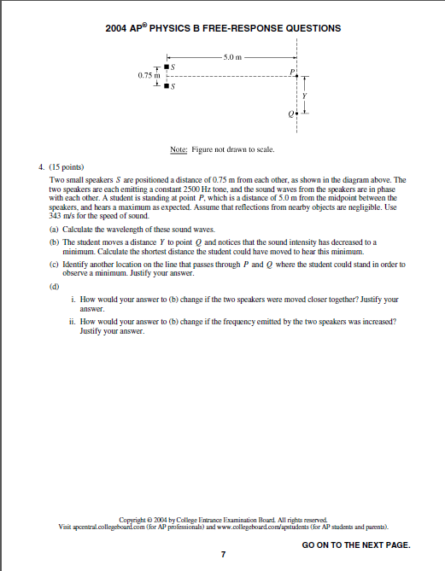
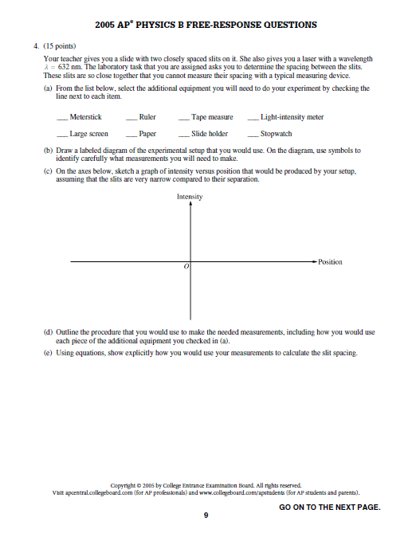

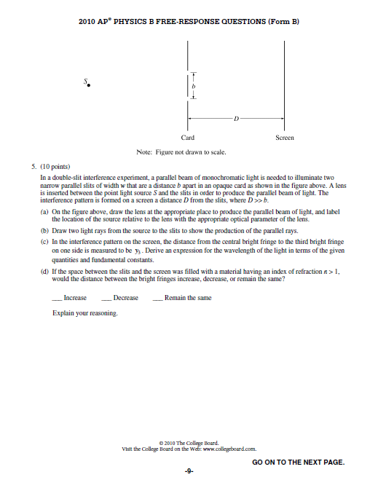
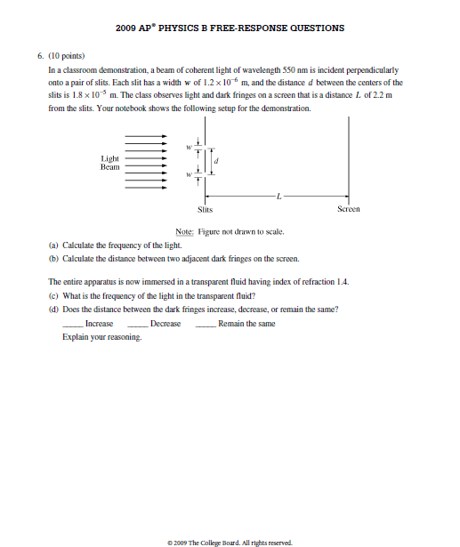

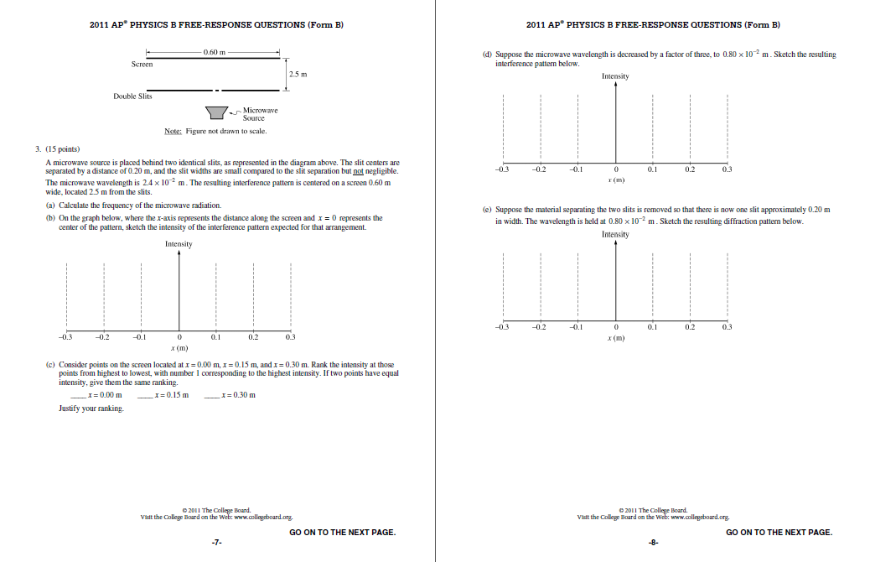

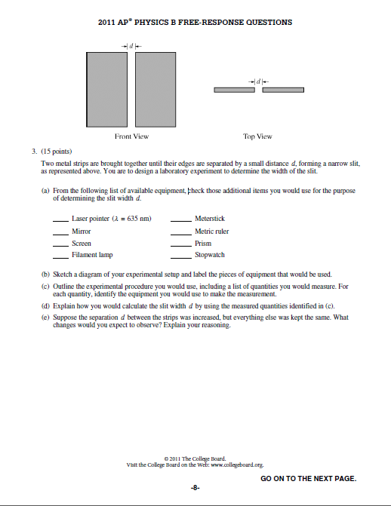

Single and Double Slits
Basic Formulas: $\sin{θ}=\frac{mλ}{d}$
$\tan{θ}=\frac{x}{L}$
$$\sin{θ}≈\tan{θ};x≈\frac{mλL}{d}$$
Single Slit Definition of Variables:
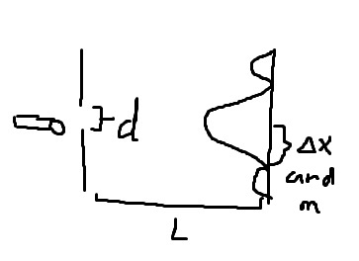
m=order of destructive interference fringes (except when m=0)
m+1/2=order of constructive interference fringes
d=length of “hole” between two slits
x=distance between minima

Double Slit Definition of Variables:
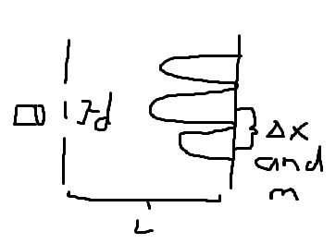
m=order of constructive interference fringes
m+1/2=order of destructive interference fringes
d=length of “slit” between two slits
x= distance between maxima

*L and λ are the same for both:
L=distance between slits and screen
λ=wavelength of light

Lab-Like Questions Tips:
- Stopwatch most likely isn’t needed
- Remember to say “shine the laser through the slit” to gain full points.
- Drawings of setup should look similar to the ones above, with corresponding labels.
