Rotational Motion Test
MCQ 1point each
- A small solid cylinder rolls up along a curved surface (fig.) with an initial velocity v. It will ascend up to a height ‘h’ equal to

(a) 3v2/2g

(b) 3v2/4g

(c) v2/2g

(d) v2/4g

(e)3v2/g

- A small cylinder rolling with a velocity v along a horizontal surface encounters a smooth inclined surface. The height ‘h’ up to which the cylinder will ascend is

(a) 3v2/2g

(b) 3v2/4g

(c) v2/2g

(d) v2/4g

(e)3v2/g

- Two inclined planes have same height but different lengths (and therefore different angles). If a solid sphere is allowed to roll down from the top of these inclined planes

(a) the time of descent will be same, but the speed at the bottom of the plane will be greater for the longer plane

(b) the time of descent will be same, but the speed at the bottom of the plane will be smaller for the longer plane

(c) the time of descent and the speed at the bottom will be same in both cases

(d) time of descent will be different, but the speed at the bottom will be same in both cases

(e) speeds and the times of descent will be different

4. Moment of inertia of a body does not depend upon its
(a) mass (b) axis of rotation (c) shape (d) distribution of mass (e) angular velocity

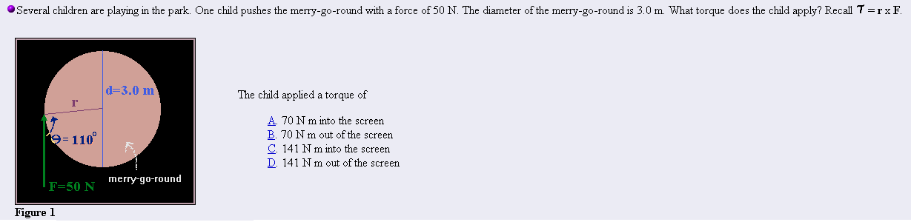

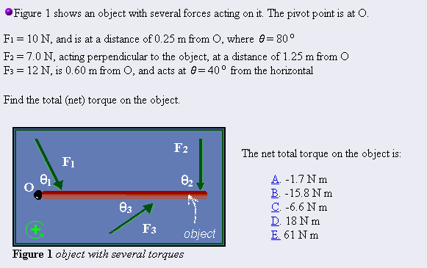

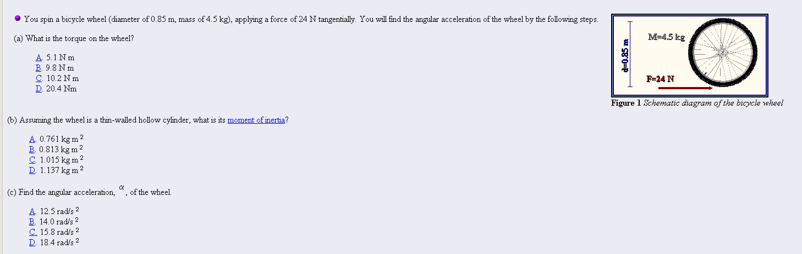

Free Response: 2 points per subquestion
