- Since the cylinder is rolling, it has translational and rotational kinetic energies. The total kinetic energy is K = (½) Mv2 + (½) Iω2 where M is the mass, I is the moment of inertia and ω is the angular velocity of the cylinder. At the highest point, the kinetic energy will be zero since the entire energy will be converted into gravitational potential energy Mgh where h is the height. So. we have

(½) Mv2 + (½) Iω2 = Mgh

The moment of inertia of the cylinder about its own axis is I = (½) MR2 where R is the radius of the cylinder. The angular velocity ω = v/R. Substituting these in the above equation,

(½) Mv2 + (½)×(½) MR2 ×v2/R2 = Mgh

Or, (¾)Mv2 = Mgh, from which h = 3v2/4g

- You should remember that a body can roll along a surface only if the surface is rough (so that there is frictional force). On a smooth surface the body can slide; but it cannot have a linear displacement by rolling. [You might have seen how a car tyre rotates in mud without producing any movement of the car].
In the present problem, the body will roll up to the foot of the inclined smooth surface. It will continue to spin with the angular speed it has acquired, and will slide up to a certain height, maintaining its spin motion throughout the smooth surface. Its translational kinetic energy alone is responsible for its upward motion along the smooth incline so that the height up to which it will rise is given by

(½) Mv2 = Mgh

Therefore, h = v2/2g.

- A body rolling down an inclined plane has greater acceleration if the angle (θ) of the plane is greater.

The length of the steeper inclined plane is smaller since the planes have the same height. Because of the larger value of θ and the smaller distance to be traveled, the time taken in the case of the shorter plane is smaller.

The velocity of the sphere at the bottom of the plane is determined by the height of the plane since the kinetic energy at the bottom is equal to the gravitational potential energy at the top, as we have seen in the previous question.

[In the case of a sphere, the equation will be (½) Mv2 + (½)×(2/5)) MR2 ×v2/R2 = Mgh, since the moment of inertia is (2/5)) MR2].

Since the height is the same, the speed at the bottom will be the same. Therefore, the correct option is (d).

- Moment of inertia is analogous to the mass of the object and is independent of the angular velocity.

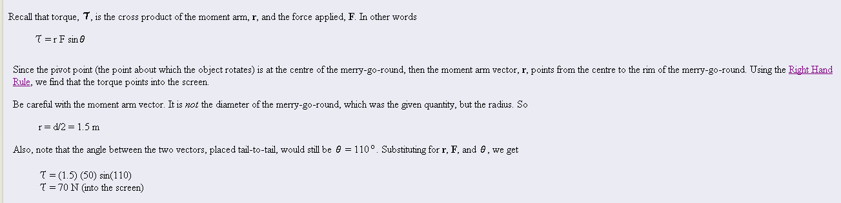
5.

6.
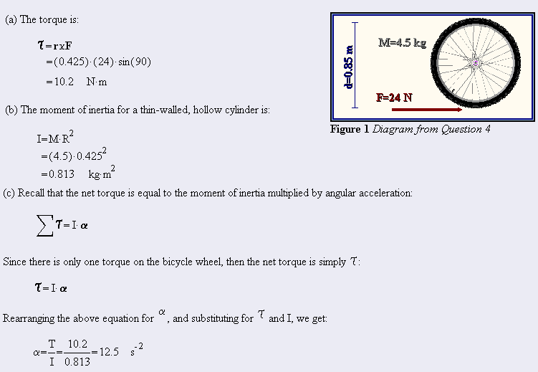

7.
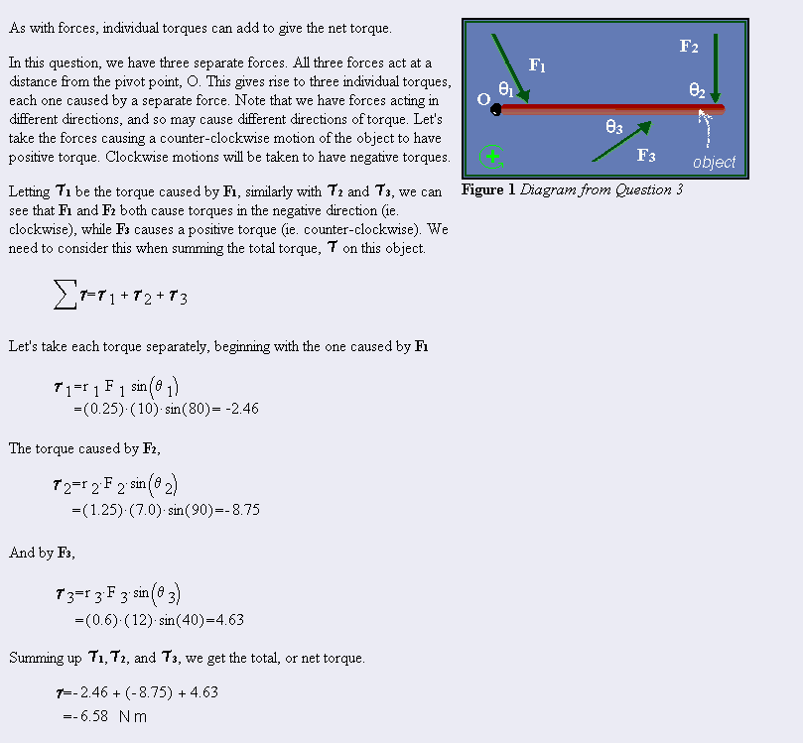

Free Response: