**Extra Practice Questions**

#11





#21

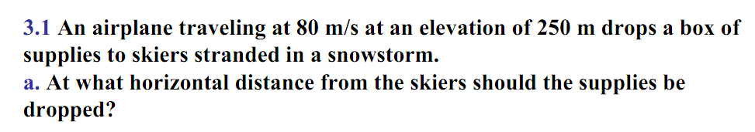

#31

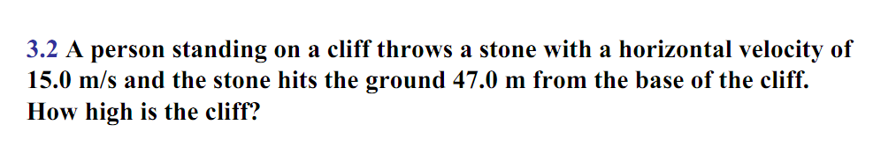

#41