Practice Test

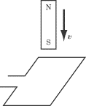

1. A bar magnet is moving downward, south pole first, toward a loop of wire. Which of the following best describes the current induced in the wire?
   1. Clockwise, as viewed from above
   2. Counterclockwise, as viewed from above
   3. The current alternates
   4. There is no current induced in the wire
   5. The direction of the current cannot be determined from the information given here

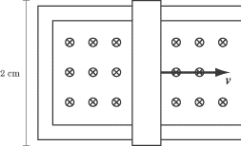

1. A bar of length 2 cm slides along metal rails at a speed of 1 cm/s. The bar and rails are in a magnetic field of 2 T, pointing out of the page. What is the induced emf in the bar and rails?
   1. http://img.sparknotes.com/content/testprep/bookimgs/sat2/physics/0008/phy.total.SMALL847.gifV
   2. http://img.sparknotes.com/content/testprep/bookimgs/sat2/physics/0008/phy.total.SMALL848.gifV
   3. http://img.sparknotes.com/content/testprep/bookimgs/sat2/physics/0008/phy.total.SMALL849.gifV
   4. http://img.sparknotes.com/content/testprep/bookimgs/sat2/physics/0008/phy.total.SMALL850.gifV
   5. http://img.sparknotes.com/content/testprep/bookimgs/sat2/physics/0008/phy.total.SMALL851.gifV

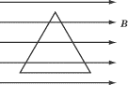

1. A wire in the shape of an equilateral triangle with sides of length 1 m sits in a magnetic field of 2 T, pointing to the right. What is the magnitude of the magnetic flux through the triangle?
   1. 0 Wb
   2. 1 Wb
   3. 1.73 Wb
   4. 2 Wb
   5. 3.46 Wb
2. A device that transforms mechanical energy into electrical energy is called a:
   1. Transformer
   2. Inductor
   3. Motor
   4. Galvanometer
   5. Generator
3. Which of the following uses the principle of electromagnetic induction?
   1. Resistor
   2. Electric generator
   3. Electric motor
   4. Capacitor
   5. Voltmeter

Free Response:













