**Assess Yourself** (Answers & Annotations)

Simply, apply Coulomb’s Law

But remember to plug in radius correctly.

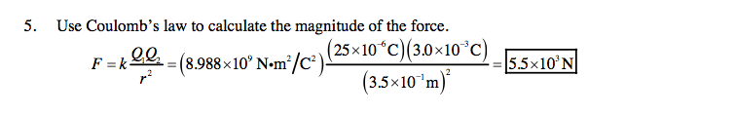

Be careful with the angles when doing sin and cos and the Pythagorean theorem.

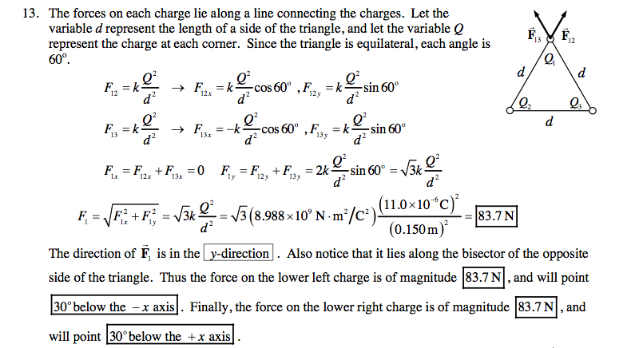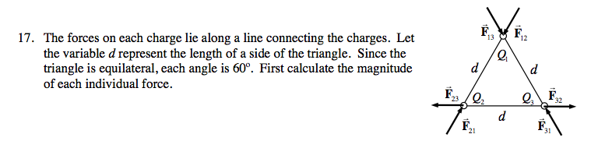

You have to calculate the relations and forces between each charges individually before determining the angles and final movements/forces.

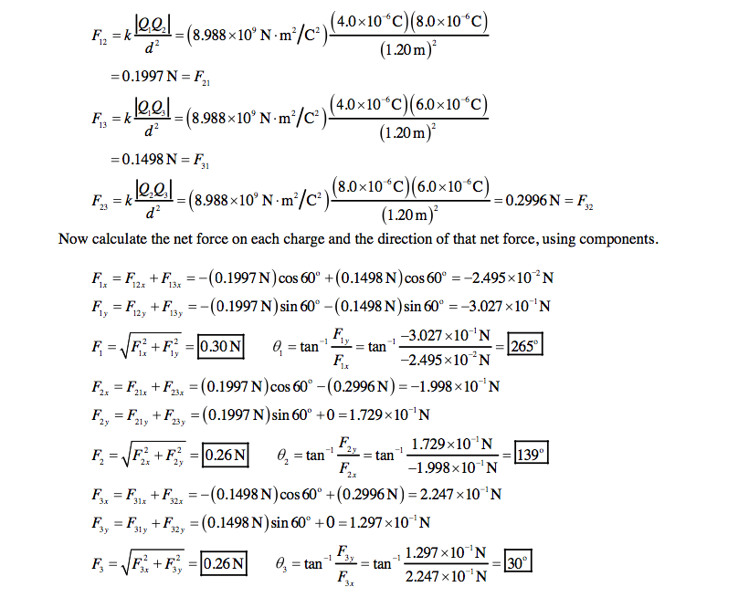

With a single sphere (Q), one of the q has to be canceled out in order to calculate the electrons.

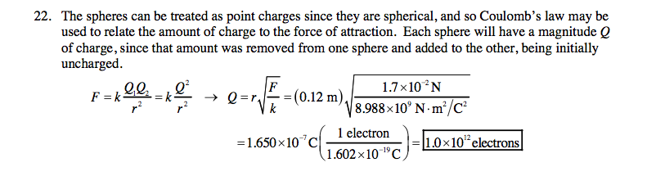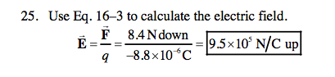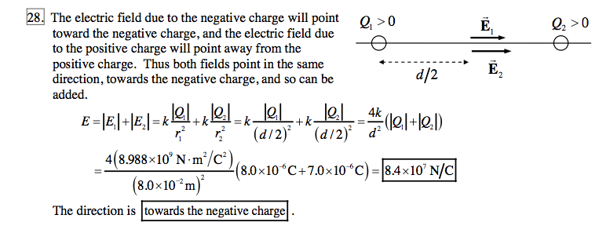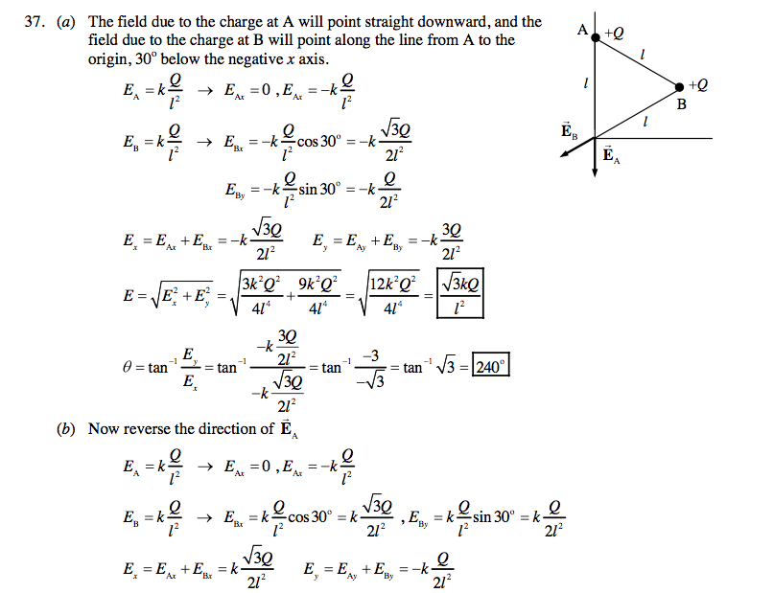

Here, it’s necessary to apply both Coulomb’s law and the equation E=F/q.

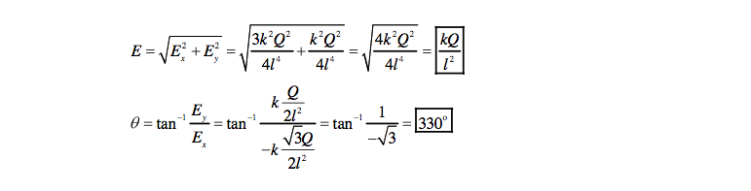

The same concepts of electrostatic applies here, but since there’s multiple angles involved, be careful when calculating the sin, cos part.

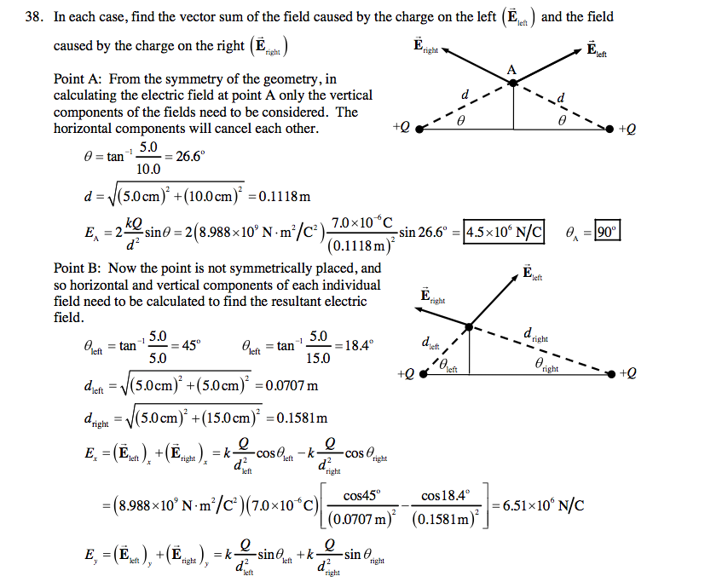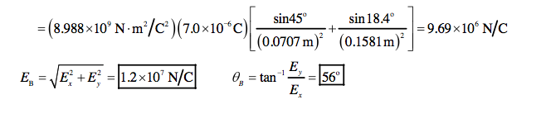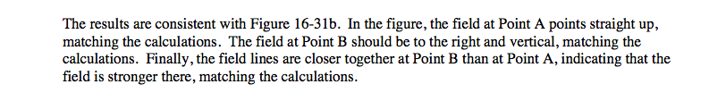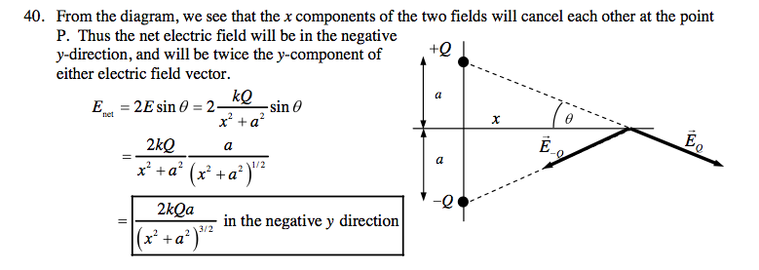

Must check the signs of each charge and make an estimate before calculating in order to get a general idea of the resultant force and field.

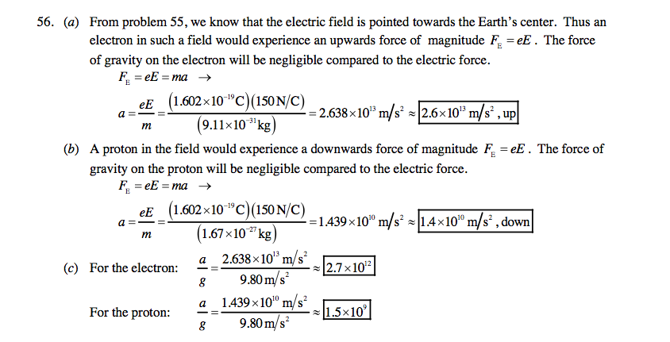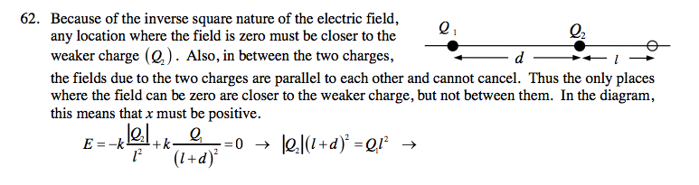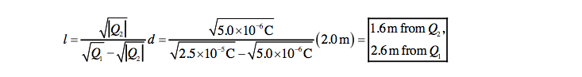

Not only does the electric forces through Coulomb’s law apply but also the laws of kinematics such as weight equals mg.

